****

Family Weekend Retreat

Memorial Day Weekend

May 26 - 28, 2017

### 

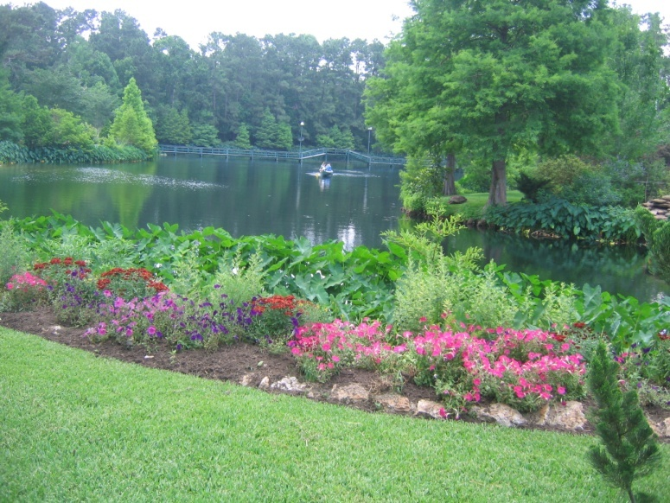

### For families seeking direction for our times with Heaven as the ultimate destination.

### Fun, fellowship, worship, and relaxation for the whole family while discovering how God is calling your family to serve in everyday life and beyond.

Circle Lake Retreat Center

Pinehurst, Texas

**WEEKEND HIGHLIGHTS**

****

* Adult and Teen group Sessions
* Supervised Faith Activities for Kids
* Family Bonding Exercise

Spiritual

Formation

[](http://www.bing.com/images/search?q=praise+worship+clip+art&view=detail&id=BB4016B97582F81C1ED2BBD48BFF2BAEE9BAF928&first=0&qpvt=praise+worship+clip+art&FORM=IDFRIR)

* Reconciliation
* Eucharistic Adoration
* Mass
* Living Rosary and Way of the Cross

Praise & Worship

pe02632_

* Family Games and competitions
* Campfire with Music and S’mores
* Free Time - Canoeing, fishing, nature trails, swimming pools, playgrounds

Family

Fun

**TIME:**

Check in: Friday 3:00 – 6:00 pm

Start: Friday 7:00 pm

Check out: Sunday 12:00 Noon

**FOR INFORMATION CONTACT:**

Host Family: Scott and Gina Bergeron

(281) 392-1342

email: [info@catholicfamilyretreat.org](mailto:info@catholicfamilyretreat.org)

[www.catholicfamilyretreat.org](http://www.catholicfamilyretreat.org)

Circle Lake Retreat Center

[www.circlelakeretreat.org](http://www.circlelakeretreat.org)

Direction for Our Times

[www.directionforourtimes.com](http://www.directionforourtimes.com)

**COST:**

* $100 registration fee per family to attend which includes 3 meals
* $350 for 2-night stay cabin rental

****

**Circle Lake Family Retreat Center**

**19000 Circle Lake Drive**

**Pinehurst, Texas 77362-1408**

Circle Lake is located on 45 piney acres including 15 acres of stocked lakes just 40 miles northwest of downtown Houston. The center is operated by the Archdiocese of Galveston-Houston and is designed as a place where family members can grow closer to God through prayer, sharing faith, learning, and playing together.

The center features 14 beautifully landscaped, 1500+ sq.ft. homes. Houses are in configurations that may accommodate from 5-15 persons. Total number of beds is 107.  Maximum occupancy is 130.

